UIT UNIVERSITY

Forth Semester B.E. Tech. (Computer) Mid Term Exam Fall 2024

Database Application CET-224

Time allowed: 90 mins Max Marks: 20

Instructions:

* Attempt All Question.
* Carefully read all questions first, and seek clarification if needed.
* No queries regarding the question paper will be entertained after 20 minutes from the start.
* Do not write on the question paper unless specifically instructed to do so.
* Ensure all required information is filled out, and return the question paper along with your answer script.

Name _______________________________ Roll No.________________________________

1. [Marks-05]- [CLO# 01]

Explain the differences between the Conceptual Data Model, Representational Data Model, and Physical Data Model. How does each model contribute to the design and implementation of a database system?

Ans: The conceptual data model describes the database at a very high level and is useful to understand the needs or requirements of the database. This model is used in the requirement-gathering process for example before the Database Designers start making a particular database. One such popular model is the entity/relationship model (ER model). The E/R model specializes in entities, relationships, and even attributes that are used by database designers.

Representational model data model is used to represent only the logical part of the database and does not represent the physical structure of the database. The representational data model allows us to focus primarily, on the design part of the database. A popular representational model is a Relational model.  In the Relational Model, we basically use tables to represent our data and the relationships between them. It is a theoretical concept whose practical implementation is done in Physical Data Model.

The Physical Data Model is used to practically implement Relational Data Model. All data in a database is stored physically on a secondary storage device such as discs and tapes. This is stored in the form of files, records, and certain other data structures. It has all the information on the format in which the files are present and the structure of the databases, the presence of external data structures, and their relation to each other. we basically save tables in memory so they can be accessed efficiently. In order to come up with a good physical model, we have to work on the relational model in a better way. Structured Query Language (SQL) is used to practically implement Relational Algebra.

1. [Marks-05]- [CLO# 01]

Evaluate the role of different database languages (such as SQL, DDL, DML, and DCL) in the management and manipulation of data in a relational database system. Compare and contrast the functionalities of these languages and explain how they work together to support efficient data handling. Analyze how the choice of language affects the performance and security of the system.

Ans: Structural Query Language (SQL) is the overarching language for interacting with relational databases. It includes sublanguages like **DDL**, **DML**, **DCL**, and **TCL** (Transaction Control Language), which cater to different needs.

Data Definition Language (DDL) languages used to define and manage the database structure. DDL deals with database schemas and descriptions of how the data should reside in the database. Key command are: Create, alter, drop and truncate. DDL Establishes the schema that forms the structural foundation of the database. It allows developers and administrators to design the blueprint of data storage.

Data Manipulation Language (DML) it is used to store, modify, retrieve, delete and update data in a database. DML is used handles data operations such as querying, inserting, updating, and deleting. DML enables users to interact with data dynamically. DML facilitates CRUD (Create, Read, Update, Delete) operations, making it essential for application integration and user queries.

Data Control Language (DCL) acts as an access specifier to the database. Basically to grant and revoke permissions to users in the database. DCL manages user permissions and database security. Key command are Grant and Revoke. It controls access to database objects, ensuring data security and compliance. Also plays a critical role in multi-user environments by restricting unauthorized actions.

Transaction Control Language (TCL) acts as a manager for all types of transactional data and all transactions. TCL manages database transactions to ensure data integrity. Key commands are: Commit, Revoke and Save point. TCL maintains consistency and ensures atomicity of operations.

|  |  |  |  |  |  |  |  |  |  |  |  |  |  |  |  |  |  |  |  |  |  |  |  |  |  |  |
| --- | --- | --- | --- | --- | --- | --- | --- | --- | --- | --- | --- | --- | --- | --- | --- | --- | --- | --- | --- | --- | --- | --- | --- | --- | --- | --- |
| |  |  |  |  |  |  |  |  |  |  |  |  |  |  |  |  |  |  |  |  |  |  |  |  |  |  | | --- | --- | --- | --- | --- | --- | --- | --- | --- | --- | --- | --- | --- | --- | --- | --- | --- | --- | --- | --- | --- | --- | --- | --- | --- | --- | | | **Aspect** | **DDL** | **DML** | **DCL** | **TCL** | | --- | --- | --- | --- | --- | | **Primary Focus** | Structure and schema | Data manipulation | Security and permissions | Transaction management | | **Level of Operation** | Database-level | Row/record-level | User/role-level | Transaction-level | | **Key Commands** | CREATE, ALTER | SELECT, INSERT | GRANT, REVOKE | COMMIT, ROLLBACK | | **System Impact** | Affects structure | Modifies/queries data | Manages access control | Ensures consistency | | |

**How They Work Together:**

DDL defines the structure of the database. DML populates and manipulates the data within this structure. DCL secures the database and enforces rules about who can use DDL and DML commands. TCL ensures all operations are completed as atomic units, maintaining consistency.

**Impact of Language Choice on Performance and Security:**

For the performance we will choose languages such DDL, DML, DCL. DDL used efficient schema design improves query execution times and storage utilization. DML well-optimized queries (e.g., using indexed columns in WHERE clauses) reduce execution time. TCL long running transaction can lead to resource locks and degrade performance.

DCL is central to enforcing security. Sensitive tables can be secured by granting access only to specific roles. Combining DCL with encryption mechanisms ensures data is protected from unauthorized users.

1. [Marks-05]- [CLO# 02]

Design an Entity-Relationship Diagram (ERD) using Chen notation for given scenario. Justify your choices of attributes for each entity.

* An INVOICE is written by a SALESREP. Each sales representative can write many invoices, but each invoice is written by a single sales representative.
* The INVOICE is written for a single CUSTOMER. However, each customer can have many invoices
* An INVOICE may include many detailed lines (LINE) which describe the PRODUCTs bought by the customer.
* An invoice LINE references one PRODUCT, and a PRODUCT may be referenced in one or more invoice LINEs

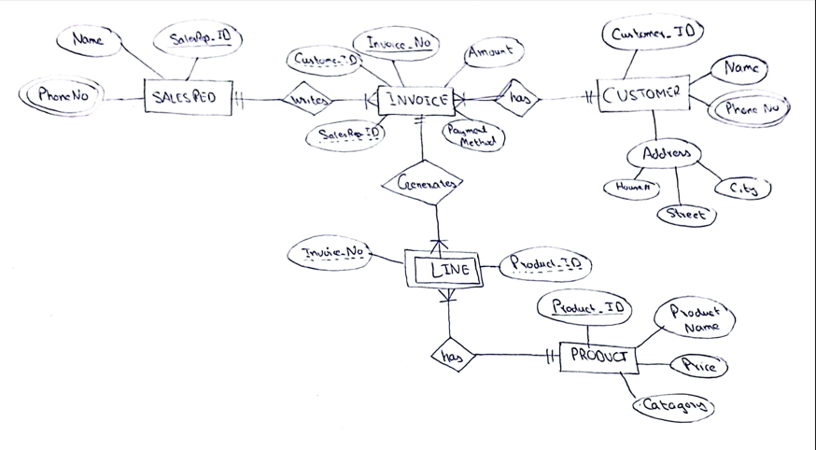

1. [Marks-05]- [CLO# 02]

Explain the Entity-Relationship (ER) model and its components. How do primary keys, foreign keys, and composite keys function within an ER model? Provide examples to illustrate their roles in ensuring data integrity.

The ER model was created to provide a simple and understandable model for representing the structure and logic of databases. The Entity Relational Model is a model for identifying entities to be represented in the database and representation of how those entities are related. The ER data model specifies enterprise schema that represents the overall logical structure of a database graphically. The Entity Relationship Diagram explains the relationship among the entities present in the database. ER models are used to model real-world objects like a person, a car, or a company and the relation between these real-world objects. In short, the ER Diagram is the structural format of the database.

What is Entity?

An Entity may be an object with a physical existence – a particular person, car, house, or employee – or it may be an object with a conceptual existence – a company, a job, or a university course.

What is Attributes?

Attributes are the properties that define the entity type. For example, Roll_No, Name, DOB, Age, Address, and Mobile_No are the attributes that define entity type Student. In ER diagram, the attribute is represented by an oval.

Relationship Type

A Relationship Type represents the association between entity types. For example, ‘Enrolled in’ is a relationship type that exists between entity type Student and Course. In ER diagram, the relationship type is represented by a diamond and connecting the entities with lines. Types of relationships:

One-to-One (1:1): One entity instance relates to only one instance of another entity.

One-to-Many (1:M): One entity instance relates to multiple instances of another entity.

Many-to-Many (M:M): Multiple instances of one entity relate to multiple instances of another.

Primary key is a unique identifier for each instance of an entity. Primary key guarantees that each record in a table is unique and identifiable. Primary key prevents duplicate or ambiguous records. Foreign key is an attribute in one entity that references the primary key in another entity. Its establishes and enforces a relationship between two entities. It prevents orphan records. Composite key provides a unique identifier when a single attribute isn’t sufficient. Provides a unique identifier when a single attribute isn’t sufficient.

Consider an example of university database. It has three entities such as student, course and enrollment. Relation is student enrolls in course and course has enrollment. Primary keys are StudentID in Student, CourseID in Course. StudentID and CourseID in Enrollment referencing Student and Course respectively. Each student can enroll in multiple courses, but each enrollment entry is uniquely identified by the composite key. Foreign key constraints ensure that only valid students and courses exist in the Enrollment table.